from __future__ import print_function  
from pyfiglet import figlet_format  
  
  
print( figlet_format("Cesar by Elienis", font = "cybermedium" ) )  
  
  
def main():  
 message = input("Introducir Mensaje: ")  
 key = int(input("Elige una Clave [1-26]: "))  
 mode = input("quieres Cifrar o Descifrar [c/d]: ")  
  
 if mode.lower().startswith('c'):  
 mode = "cifrar"  
 elif mode.lower().startswith('d'):  
 mode = "descifrar"  
  
 translated = encdec(message, key, mode)  
 if mode == "cifrar":  
 print(("Tu Mensaje Cifrado es:", translated))  
 elif mode == "descifrar":  
 print(("Tu Mensaje Descifrado es:", translated))  
  
  
def encdec(message, key, mode):  
 message = message.upper()  
 translated = ""  
 LETTERS = "ABCDEFGHIJKLMNOPQRSTUVWXYZ"  
 for symbol in message:  
 if symbol in LETTERS:  
 num = LETTERS.find(symbol)  
 if mode == "cifrar":  
 num = num + key  
 elif mode == "descifrar":  
 num = num - key  
  
 if num >= len(LETTERS):  
 num -= len(LETTERS)  
 elif num < 0:  
 num += len(LETTERS)  
  
 translated += LETTERS[num]  
 else:  
 translated += symbol  
 return translated  
  
  
if __name__ == '__main__':  
 import doctest  
  
 doctest.testmod()  
 main()  
 input()  
  
 print(figlet_format("gracias por usar", font="cybermedium"))

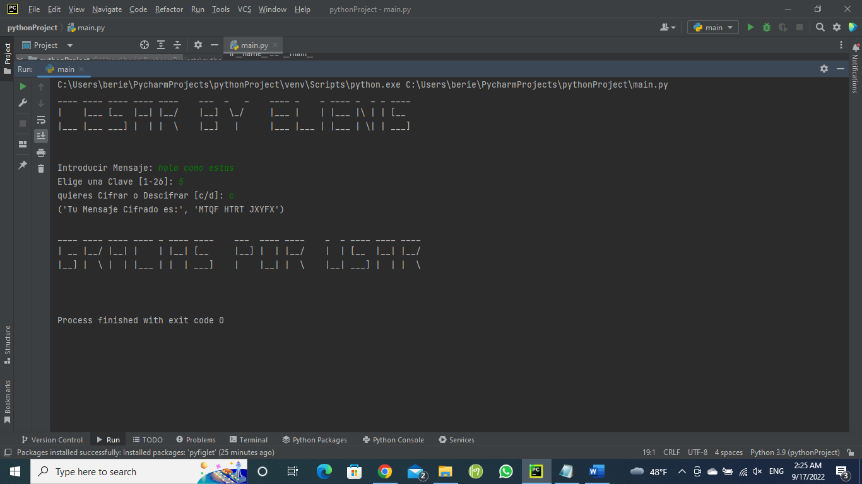

from pyfiglet import figlet_format  
  
  
print( figlet_format("Atbash by Elienis", font = "cybermedium" ) )  
  
  
  
def atbash(message):  
 ABC = 'ABCDEFGHIJKLMNOPQRSTUVWXYZ'  
 ZYX = 'ZYXWVUTSRQPONMLKJIHGFEDCBA'  
 result = ''  
  
 for letter in message:  
 result += ZYX[ABC.index(letter)]  
  
 return result  
  
if __name__ == "__main__":   
 message = input('Escribe un mensaje y presione enter: ')  
 print(f'Resultado cifrado: { atbash(message.upper()) }')  
 print(figlet_format("gracias por usar ", font="cybermedium"))

